# Department of Computing

# CS 212: Object Oriented Programming

# Class: BSCS-8AB

# Lab 05: Inheritance

# Date: March 11, 2017

# Instructor: Hirra Anwar

**Learning Objectives**

The learning objective of this lab is to understand and practice the concept of inheritance, a very powerful feature of OOP which helps in code reusability.

**Activity #1.**

What is the output of running the class ActivityOne? Explain the output.

**Hint.** Remember only super-class data members (instance variables and instance methods) are inherited by the sub-class, and these does not include constructors.

|  |
| --- |
| class A  **{**  public A**()**  **{**  System**.**out**.**println**(** "A's no-arg constructor is invoked"**);**  **}**  **}**  class B **extends** A **{}**  public class ActivityOne  **{**  public static void main**(** String**[]** args**)**  **{**  B b **=** **new** B**();**  **}**  **}** |

**Activity #2.**

The Java program compiles correctly. Show its output, and explain what is happening when an object of Class B is created?

|  |
| --- |
| class A  **{**  public A**()**  **{**  System**.**out**.**println**(** "A's constructor is invoked"**);**  **}**  **}**  class B **extends** A  **{**  public B**(**int t**)**  **{**  System**.**out**.**println**(** "B's constructor is invoked"**);**  **}**  **}**  public class ActivityTwo  **{**  public static void main**(** String**[]** args**)**  **{**  B b **=** **new** B**(**3**);**  **}**  **}** |

**Activity #3.**

The program fails to compile. Identify the problem and propose a correction? Also explain the reason.

**Hint.** If any constructor does not explicitly call a super or this constructor as its first statement, a call to super() is automatically added.

|  |
| --- |
| class A  **{**  public A**(** int x**)** **{}**  **}**  class B **extends** A  **{**  public B**()** **{}**  **}**  public class ActivityThree  **{**  public static void main**(** String**[]** args**)**  **{**  B b **=** **new** B**();**  **}**  **}** |

**Activity #4.**

Identify and correct the problems in the following program.

|  |
| --- |
| class Circle  **{**  private double radius**;**  public Circle**(** double radius**)**  **{**  radius **=** radius**;**  **}**  public double getRadius**()**  **{**  **return** radius**;**  **}**  public double getArea**()**  **{**  **return** radius **\*** radius **\*** Math**.**PI**;**  **}**  **}**  class B **extends** Circle  **{**  private double length**;**    B**(** double radius**,** double length**)**  **{**  Circle**(** radius**);**  length **=** length**;**  **}**  /** Override getArea() */  public double getArea**()**  **{**  **return** getArea**()** **\*** length**;**  **}**  **}**  public class ActivityFour  **{**  public static void main**(** String**[]** args**)**  **{**  B b **=** **new** B**(** 5**,** 10**);**  System**.**out**.**println**(** "Area = " **+** b**.**getArea**());**  **}**  **}** |

**Task #1:**

The following UML class diagram illustrates an inheritance relationship, wherein the classes Circle and Rectangle have been extended from the class GeometricObject.

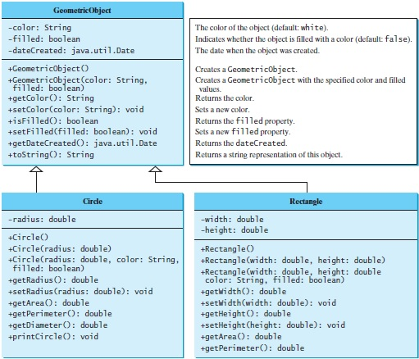

You’re required to implement the classes GeometricObject and Rectangle.

The Rectangle class contains:

* Two double data fields named width and height that specify the width and height of the rectangle. The default values are 1.0 for both width and height.
* A no-arg constructor that creates a default rectangle.
* A constructor that creates a rectangle with the specified width and height.
* A method named getArea() that returns the area of this rectangle.
* A method named getPerimeter() that returns the perimeter.
* A method named toString() that returns a string description for the rectangle.

The toString() method is implemented as follows:

return "Rectangle: width = " + width + " height = " + height;

Write a test program that prompts the user to enter width and height of the rectangle, a color, and a Boolean value to indicate whether the rectangle is filled. The program should create a Rectangle object and set the color and filled properties using the input. The program should display the area, perimeter, color, and true or false to indicate whether it is filled or not.

You can use the Date class to create the dateCreated data member or String datatype. The Date class is present in java.util package.

**Task #2:**

Design a class named Person and its two subclasses named Student and Employee. Make Faculty and Staff subclasses of Employee.

A person has a name, address, phone number, and email address. A student has a class status (freshman, sophomore, junior, or senior). Define the status as a constant. An employee has an office, salary, and date hired. A faculty member has office hours and a rank. A staff member has a title. Create a display function to display the class name and the person’s name.

Write a test program that creates a Person, Student, Employee, Faculty, and Staff, and invokes their display methods.

**Deliverable**

Compile a single word file and upload on LMS.